Quality of Service of In-Home Digital Networks

PROGRESS project EES.5653

2nd report after 15 months

Peter van der Stok, Johan Lukkien

May 17, 2004

Introduction
This document reports on PROGRESS Project "Quality of Service of In-home digital networks". The funding through PROGRESS (STW) concerns two AIO positions. TU/e has added an extra AIO to the project. The project is currently led by dr. Peter van der Stok, from Philips Research and dr. Johan Lukkien from Eindhoven University of Technology. Final responsibilities are with prof. dr. ir. Emile Aarts who is also first promotor of the AIOs.

Workers on the project are

M.Sc. Sergei Kozlov - joined January 1, 2003
M.Sc. Alina Albu MTD - joined July 1, 2003
M.Sc. Dmitri Jarnikov MTD - joined October 1, 2004

From the project description
The aim of this project is to analyze and optimize the quality of service in in-home digital networks, addressing the issue of how to optimally use distributed processing, communication, and storage resources in such a network of embedded systems, with a focus on streaming (video, audio) applications.....
..... The envisioned results of the project include mathematical models and their analysis of in-home digital networks and their components, giving insight into the problem area, rules for configuring in-home digital networks to obtain given quality-of-service levels, algorithms for load balancing of processing and storage over the nodes in a network, for scheduling processing tasks and disk accesses, and for communication flow control in a network, and implementation of the algorithms in simulation environments and prototype systems.

General approach
The concept of quality of service addresses systems in which guarantees about quality are not given but rather the quality is varied according to circumstances. The system design aims at optimizing the delivered quality given these circumstances. There are mainly two reasons for a QoS approach. First, there is a cost-performance trade-off. The performance requirements for the system may be much lower in the average case than in the worst case, rendering the worst case approach too expensive. Second, the system resources may be unpredictable in nature as is the case, for example, in wireless transmissions.
The environment considered within the project consists of delivering digital video in a networked home environment. Since the perceived quality of a video depends on the quality of the network, the quality of the video rendering CPU and the quality of the rendered video, delivering a certain quality of service involves in principle cooperation of all system components, viz., source, network and destination. We assume this system to be dynamic with mobile components and changing topology. The approach we choose is to develop an adaptive system. This leads to self-monitoring of the system and subsequent adaptation.

Changes in the delivered quality are caused through interactions with the system and through autonomous changes in the available resources. These things play on different timescales and, as a result, the monitoring and feed-back loops play at different layers of the design. For example, packet loss in a wireless link is initially dealt with in the transport and data-link protocols that run on top of it. If the loss is structural then the system needs to re-assign bandwidths.

Typical elements of a QoS system are applications or algorithms that admit tuning quality and resource use (so-called scalable algorithms) and system components that support resource allocation and enforcement. In order to let the system work smoothly, admission test are needed for newly started applications in order to predict the new situation. To that end it must be possible specify resource requirements in a similar way as we do with functional properties.

Within the project we have allocated three points of attention: scalable video algorithms, adaptive transport protocols and prediction of real-time properties.

Current Status
Sergei works on good transport protocols for video over wireless connections. Wireless communication has different properties than wired connection with respect to packet loss. The studied protocols take this into account in several ways. First, mechanisms are studied that discriminate between this type of packet loss and network congestion. Second, the transported contents is prioritized which is particularly useful for mpeg-encoded video. Part of this work has already been demonstrated at the PROGRESS workshop in October 2003. At the meeting, recent results of this work will be demonstrated.

Dmitri is working on adaptive video algorithms, based on multi-layered video streams. Initial results are on having constant quality, i.e., avoid quality fluctuations. Subsequent work will address the system architecture and feedback control. Contributions to several conferences have been accepted. An overview of results and plans will be shown at the meeting.

Alina has started with a literature overview of QoS approaches and research. This served as a means to get acquainted with the subject. The intention is to turn this work into a technical report. Next she has started to look at predicting resource requirements of components. A description of this work will be given at the meeting.

Current state of the project is further maintained on the website www.win.tue.nl/~johanl/projects/QoS. Technical reports, presentations and articles are available from there.

Embedding within organizations
All three students participate in relevant research groups and projects inside Philips and TU/e. Within Philips, they are part of the OASIS cluster that again is part of the IPA group within the IST sector at Philips Research, Natlab. They visit the cluster meetings and are associated with a Philips project: Sergei is associated with the QOSIH project (Quality of Service for In-Home networks), Alina is associated with the MRM project (Multiple Resource Management) and Dmitri is associated with the KISS project. This embedding enables them to actively participate inside the cluster and get more affinity with the questions raised by the in-home digital networks. The work of the three students is targeted at medium-term results. From Philips, their work is regarded as relevant alternatives to the ongoing work that allows the project to better motivate their final technical decisions.

Within the TU/e the students are part of the SAN expertise-area (System Architecture and Networking). One day a week is spent at the TU/e. Within SAN there is a weekly presentation of ongoing work on this day, so in this way they get to see work and people inside the group. Together with the two supervisors a QoS study group is formed that meets at least bi-weekly in the afternoon. Topics include discussions and presentations of work and discussion of relevant literature.

Plans
We continue along the lines of the plans formulated in the previous progress report (available from the site). For some time to come the work of the three students will proceed rather independently. The contributions will come together in common demonstrators.

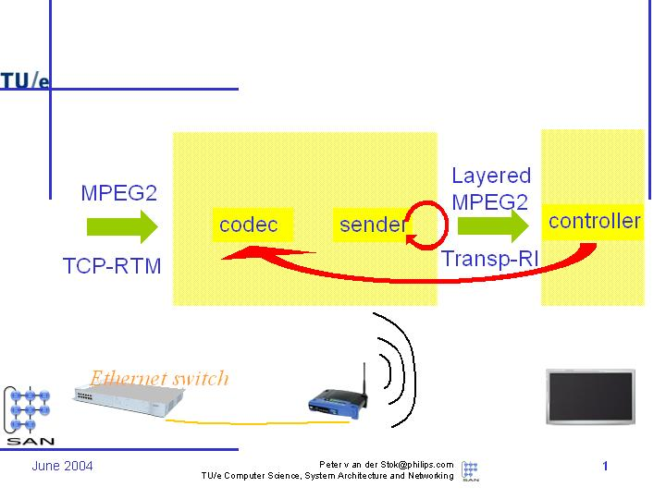
The above picture shows the framework that we have in mind. On the left video contents (at this moment MPEG2) is transported from a video source (DVD player) via the Ethernet switch to the wireless Access Point. From the Access point the stream is sent via IEEE 802.11x to a TV. The TV contains a multi-processor chip, in this case the VIPER-1. In the TV there is a controller that adapts the quality of the video treatment to the possibilities of the CPU (Viper CPUs). Two feedback loops are shown: (1) a fast one that acts on the transmission of the packets over the wireless link, and a slow one that adapts the settings of the transcoder. Alina’s work takes place in the TV CPUs. Dmitri’s work takes place in the controller and in the transcoder. Sergei’s work takes place over both network segments at both the transport layer as the data-link layer.

Output
We refer to the website.

